**Automating Your App with Elastic Beanstalk and CloudFormation**

CloudFormation : Service to provision resources using templates

Key tool in CF is a template. CF template is a JSON documner that contains config information for aws resources. can be used in version control. No limit to amount of resources.

Idea of stack - stack is essentially a group of aws resources created by a single cloud formation template.

A template can be used to create more than one stack but each stack need to be named uniquely.

Stacks can be updated and deleted

**Create, test and delete pizza luvrs infra with CF**

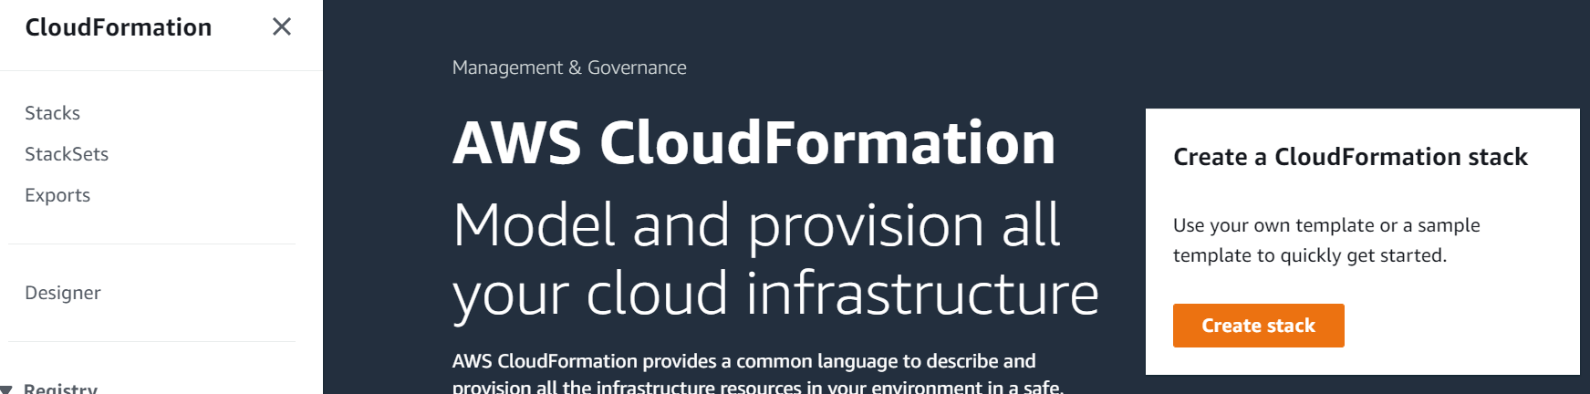

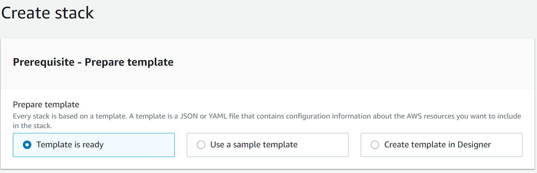

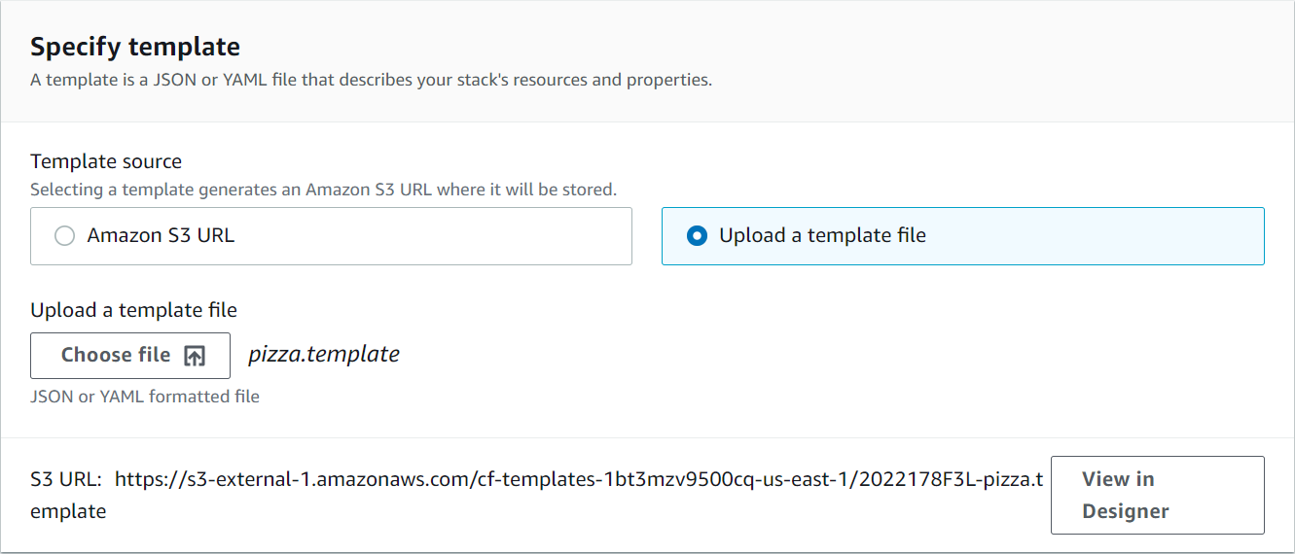

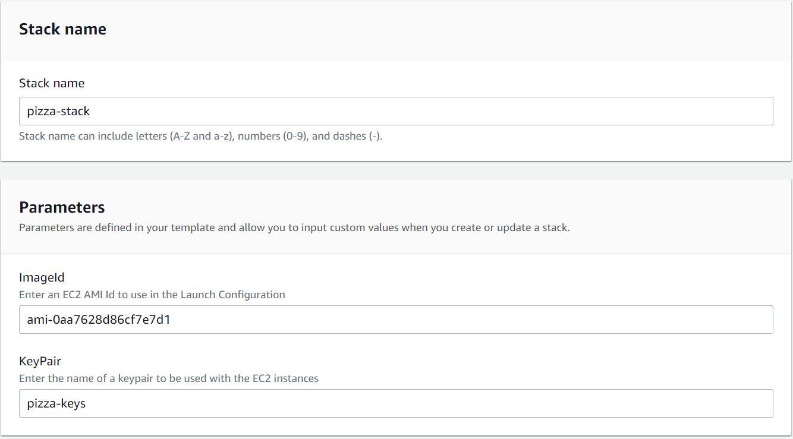

**Elastic bean :** scaling, Monitoring, Resource provisioning

need to app code to and it will take care of having the correct OS and platform installed for your application

CF only provisions resources elastic beanstalk provisions resources and runs your app

Elastic beanstalk app : represents a logical app, runs a single platform(eg : nodejs, java), has one or more app versions

**Deploying app with elastic beanstalk**

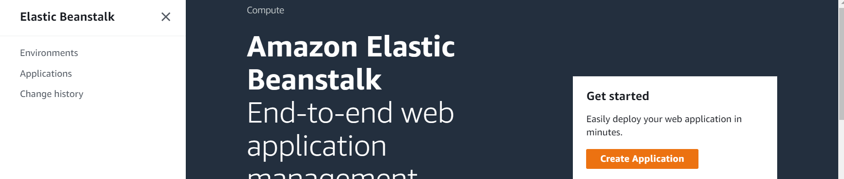

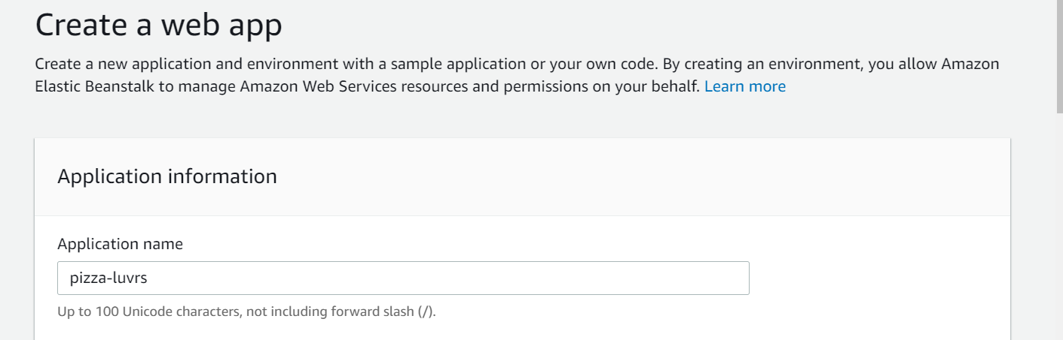

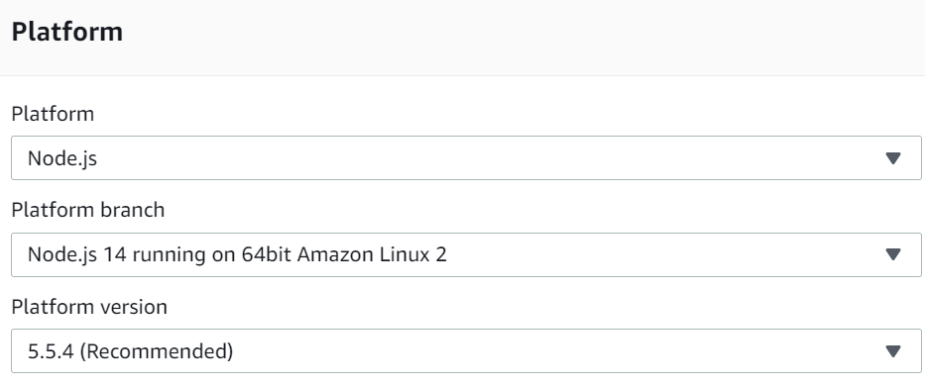

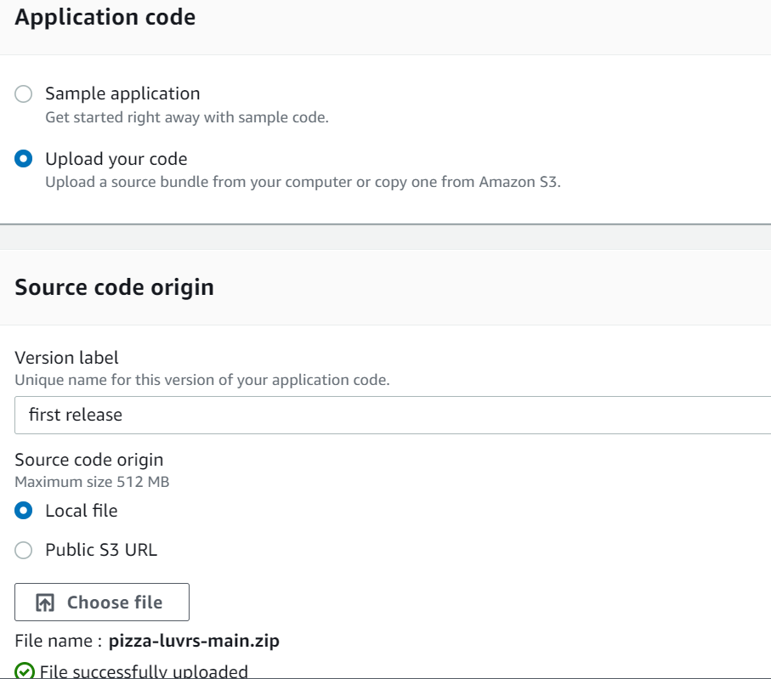

Configure more options

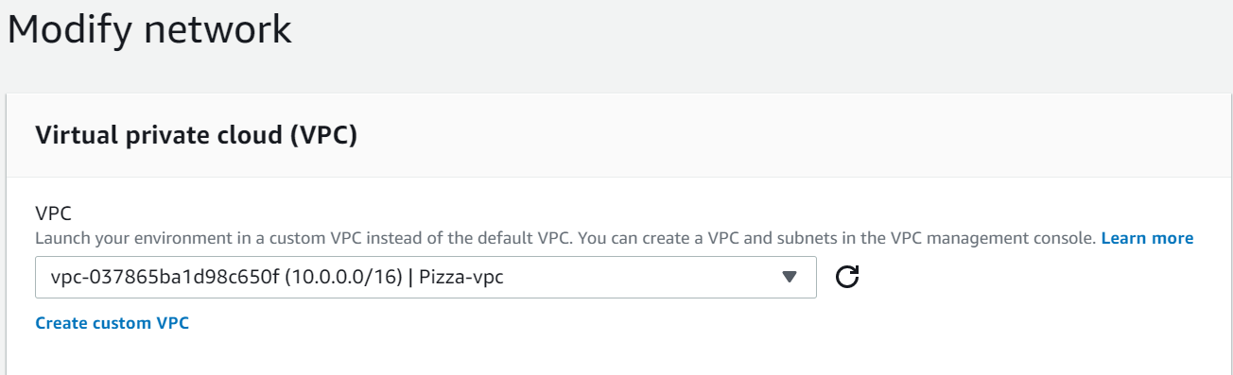

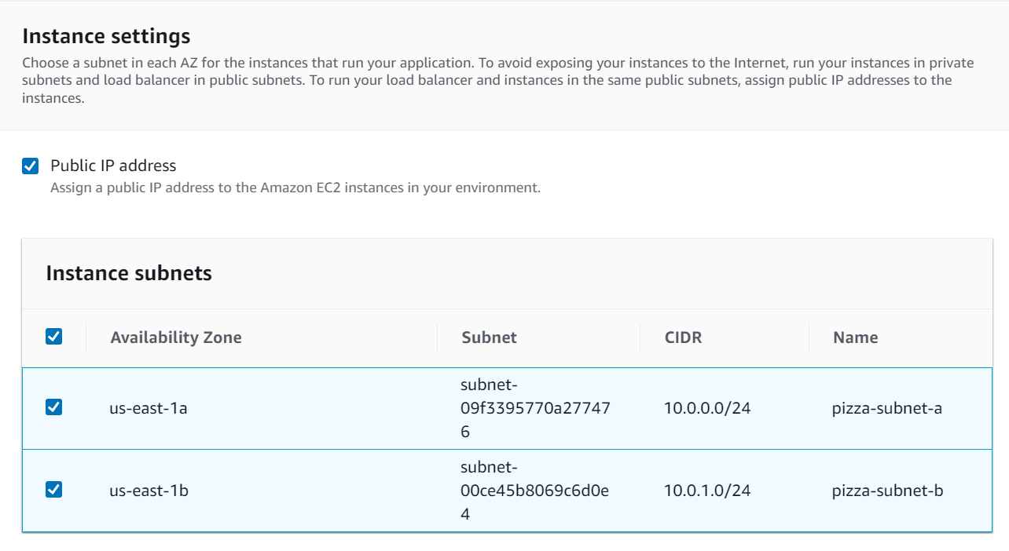

And save

Modify instance and select SG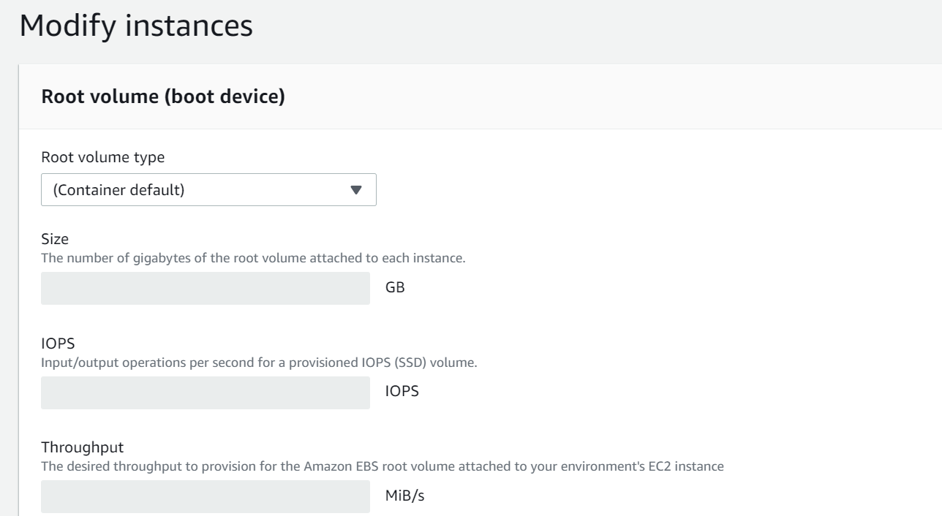

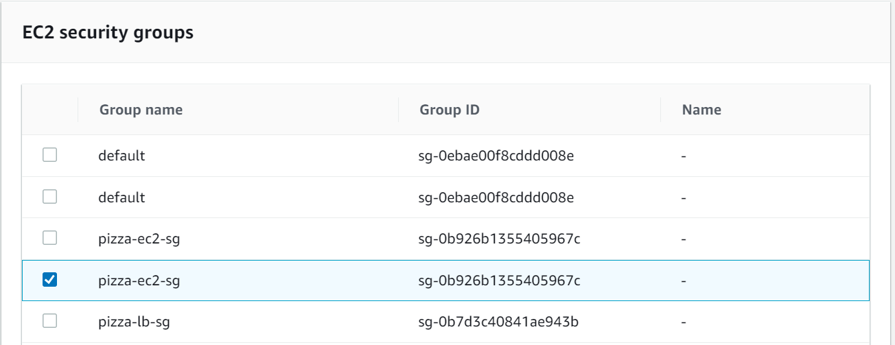

Edit security

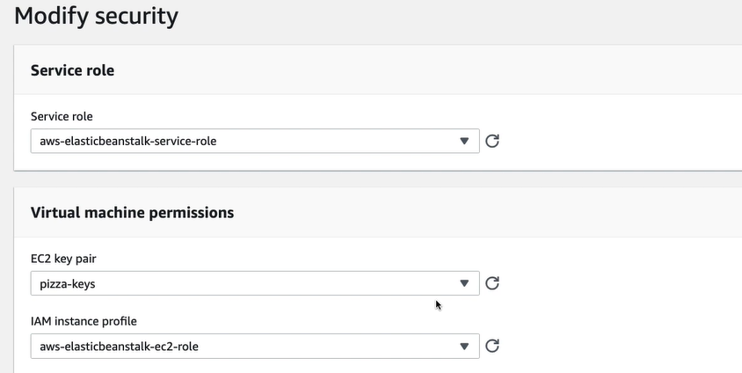

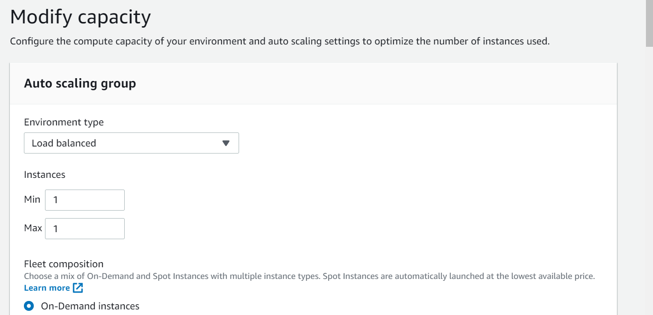

And edit load balancer

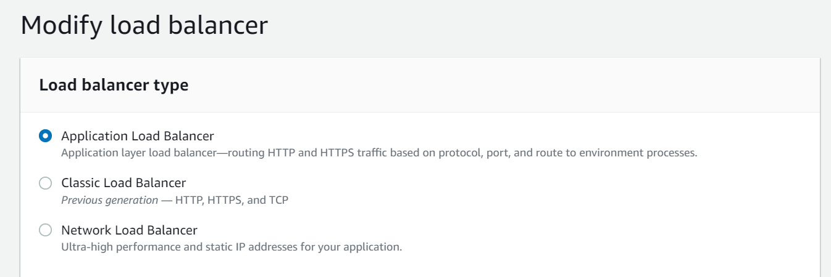

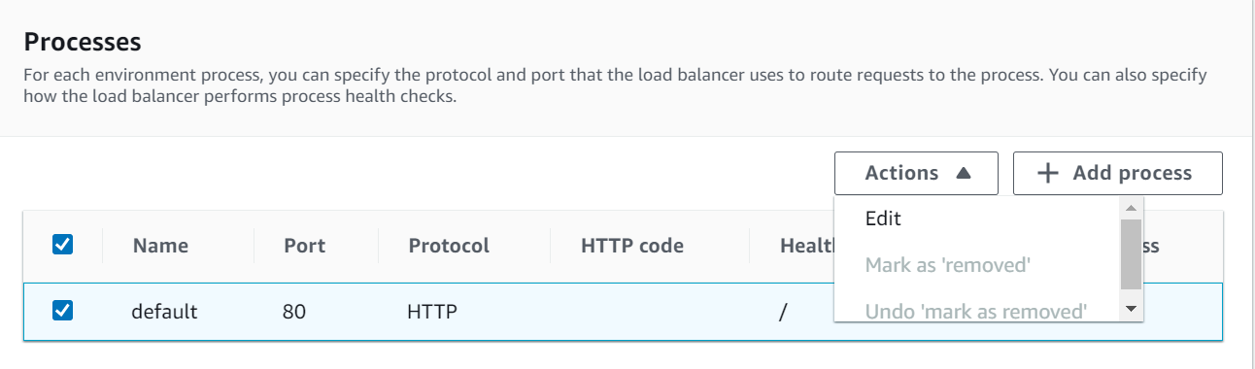

Create app

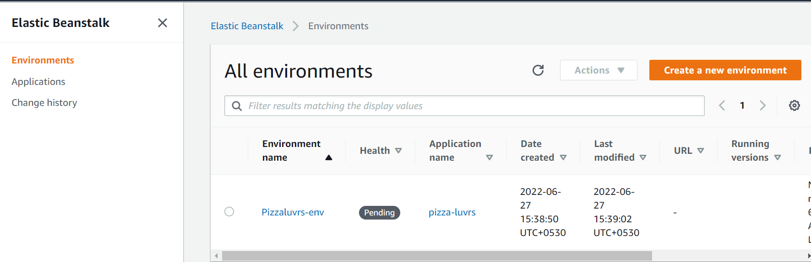

**Add RDS and Dynamo DB policies to EC2 IAM role**

IAM Dashboard-->Roles